**A Summary Project planning Report**

**For**

**Inventory Application of SMCCIT**

**Proposal for Application**

**List of Module:**

* **General Configuration**
* Vendor
* Branch
* Department
* User
* Category Setup
* Subcategory Setup
* Products
* **System Configuration**
* User Group
* Create Login Id and Password for Each User
* Assign Permissions
* Restricting User Access with Login and Password
* **Requisition**
* Get Requisition
* Inspection
* **Purchase**
* Requisition Purchase
* Inspection
* Receipt Entry
* Products Configuration
* **Distribution**
* Requisition Distribution
* **Stock**
* Product Stock
* Damage Stock
* **Report**
* Stock Report
* Leger
* Branch Wise Requisition List
* Requisition List
* Branch Wise Inventory

**Project Diagram**

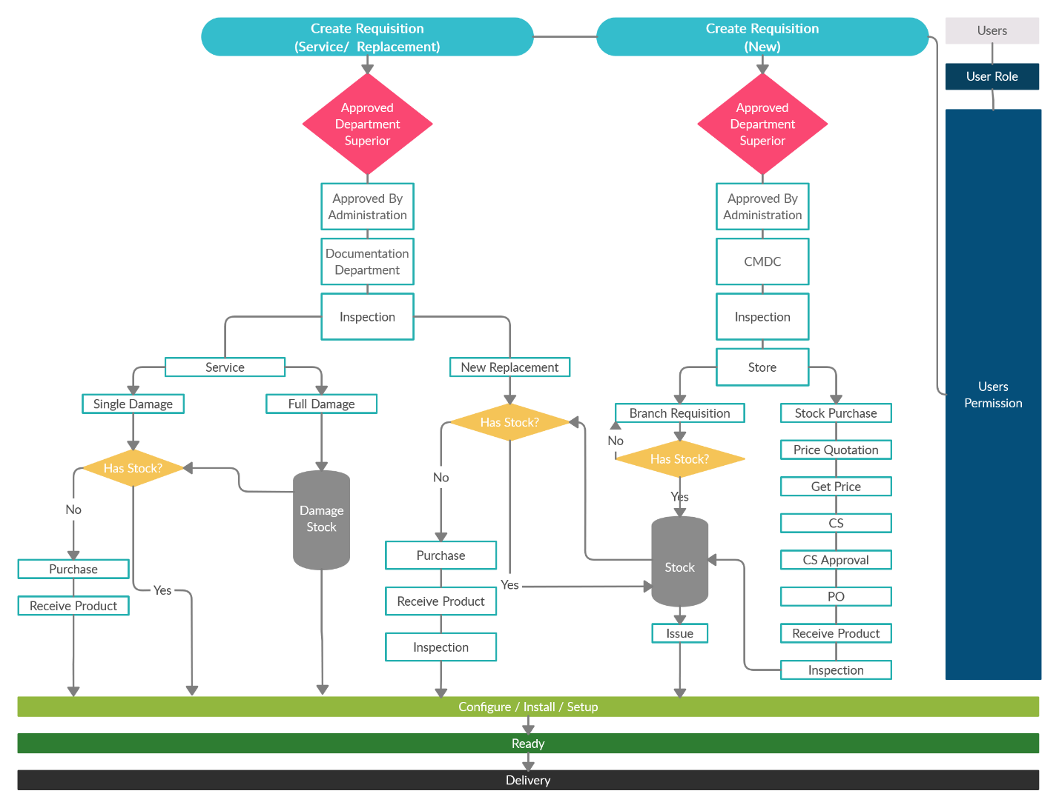

**Data Flow Diagram**

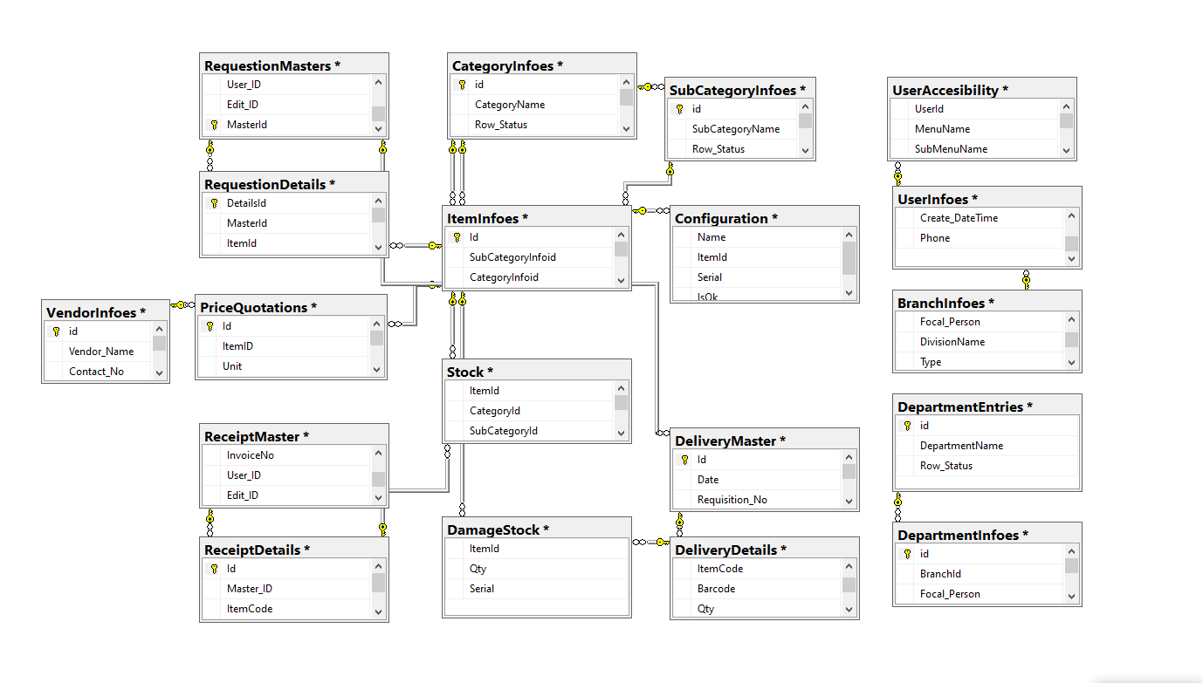

**Our Team & Leadership**

* 1. **A.M Syed, GM IT & Project Supervisor**
  2. **Uttam Kumar Dev Nath, Assistant Programmer & Backend Developer**
  3. **Asfer Nadiya, Assistant Programmer & Frontend Developer**

**Tools and Technology**

Backend: Asp.Net MVC

Frontend: HTML5, Bootstrap, JavaScript, Ajax

Database: MS SQL Server

**Time Requirement**

Estimated time for completion of our project is 120 working days which includes:

|  |  |  |
| --- | --- | --- |
| **Milestone** | **Description** | **No of Days** |
| 1. | Planning | 60 Days (Working days) |
| 2. | Concept Design |
| 3. | Primary Page Development |
| 4. | Primary Page Revision/Secondary Page Development |
| 5. | Review and Testing | 30 Days (Working days) |
| 6. | Final Revision and Acceptance | 30 Days (Working days) |